|  |  |
| --- | --- |
|  | **NETWORK AND INTERNET SOCLE**  **SOCLE IDENTITY CARD** |
|  |  |

PRESENTATION OF SOCLE ACTIVITIES

Network and Internet socle (platform) operates all the internal and external secured connectivity services, in Data Centre and on the user sites for the benefit of Crédit Agricole businesses. The main objectives of Socle correspond to the service delivery, development of a technological coherence framework and support the technological evolutions and failures which redesigns the landscape

3,700 urls accessible through Internet

5,990 agencies

Crédit Agricole

215 buildings or campus

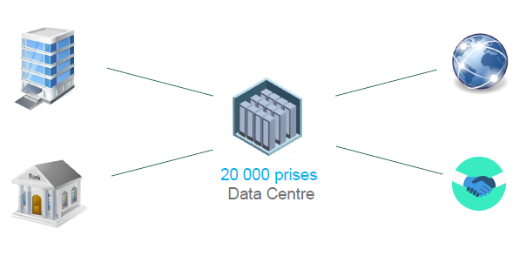

sockets

700 Partners

**ORGANISATION**

The socle is built upon the technological skills division, which are focused and highly professionalized for the various network components:

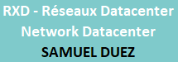 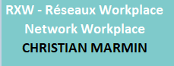 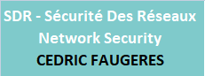 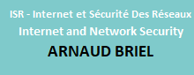  
  
Specialized 'point of contact' teams to support for Clusters and Socles:

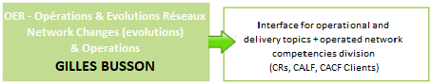 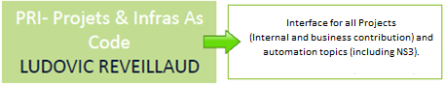  
  
A Transverse (cross-functional) team responsible for the monitoring of services related to our telecom services and quality (billing volumes, ITIL processes, contracts, etc.):

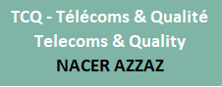 

Socle Manager



|  |  |
| --- | --- |
| How to create a request for Socle? | If offline, refer dedicated slide |

|  |  |
| --- | --- |
| Métis recovers the historical catalogs for requests from SILCA and CATS scope except opening of flows, then a standardization task begins.    <https://algosec.carmen.prodinfo.gca>  Your requests to open the flows are to be specifically created through the Fireflow tool  UserGuide: <https://service.ca-mocca.com/maia-collab/sde/PilotesAlgosecFF>  Contact: [carmen_vse@ca-gip.fr](mailto:carmen_vse@ca-gip.fr) | NS3 -Network and Security Self Service  <https://ns3.prodinfo.gca>  In its automation strategy, socle provides you with a standardized products self-service consumption portal (IPAM, DNS, F5,…) its catalogue is continuously overhauled.  User Guide: <https://wiki.saas.cagip.group.gca/>  display/CICP/Manueld'utilisation NS3  For any questions regarding this new service, please contact: [cagip_apines@cagip.fr](mailto:cagip_apines@cagip.fr) |

|  |  |  |  |
| --- | --- | --- | --- |
| What to do in case of an incident? | | If offline, refer dedicated slide | |
|  | is the preferred channel for reporting any incident | |

|  |  |  |  |  |
| --- | --- | --- | --- | --- |
|  |  |  |  |  |
|  | LAN building, Wifi,  MAN community, 802.1x  CAGIP-SRI-RXW-RES-RUN | Operated networks  (agencies, partners)  CAGIP-SRI-OER-RUN | LAN DC, F5, DNS,  CAGIP-SRI-RXD-RUN | Flow, SAS, Proxy  CAGIP-SRI-ISR-SDR_RUN |
|  | CAGIP-SRI-RUN-reseau-LAN-WAN@ca-gip.fr | | CAGIP-SRI-RUN-reseau-DC@ca-gip.fr | CAGIP-SRI-RUN-reseau-sécurité@ca-gip.fr |
| (HO) | **01 57 72 32 32** | | **01 57 72 38 38** | **01 57 72 36 36** |
| (HNO) | **CA-GIP PILOTAGE 01 42 95 95 60** | | | |

|  |  |  |
| --- | --- | --- |
| In case of malfunction or urgency: |  | Socle On-call Management  01 43 23 65 08 |

How to proceed with the Internet scope?

Request and Incident

|  |  |
| --- | --- |
|  | The portal is to be used in all cases because it allows:   * Categorization * Emergency management * A better reactivity * Request follow up   You can make a call to emphasize the urgency of a request or incident |
| In case of lack of clarity and for simplification, an Internet process comparison in Metis (similar to the other network infrastructure layers) is under study. | |

|  |  |  |
| --- | --- | --- |
| In case of malfunction or urgency: |  | Socle On-call Management  01 43 23 65 08 |



How to request the Socle in case of a project?

To request an encryption, a contribution or the delegation of a project to the network socle, here is a single point of contact: [cagip_nesproject@ca-gip.fr](mailto:cagip_nesproject@ca-gip.fr)

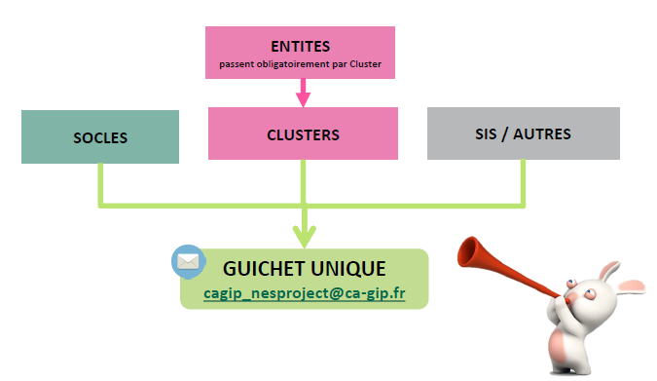

**SIS / OTHERS**

**Passing obligatorily by cluster**

**SINGLE POINT OF CONTACT**

PRIVILEGED CONTACTS

Your "points of contact" teams have assigned representatives to ensure proximity between our different teams/activities

|  |  |
| --- | --- |
|  |  |
|  | | |

Summary of the main inter-socle channels

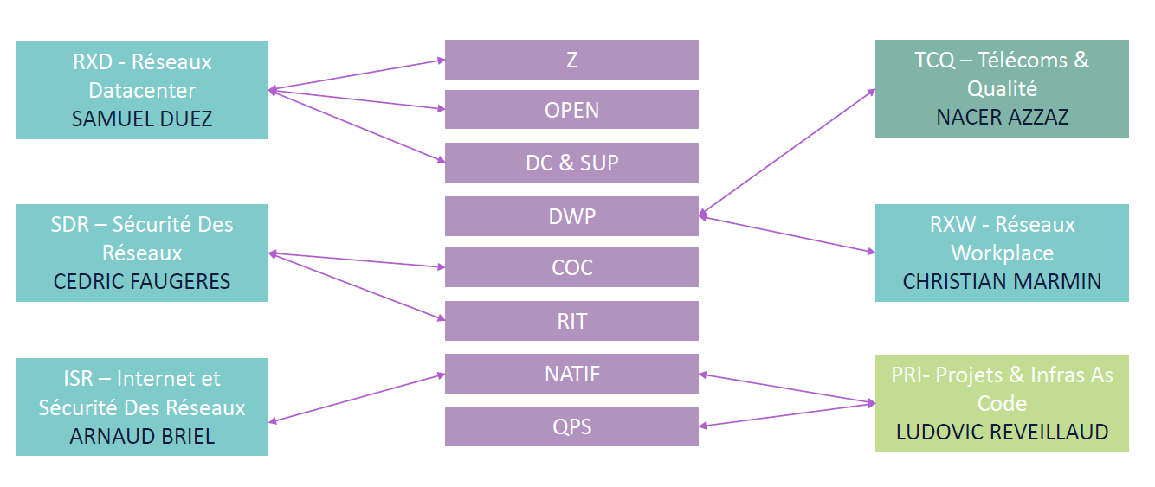

TCQ – Telecoms & Quality

& Quality

Network Workplace

Key roles within Socle

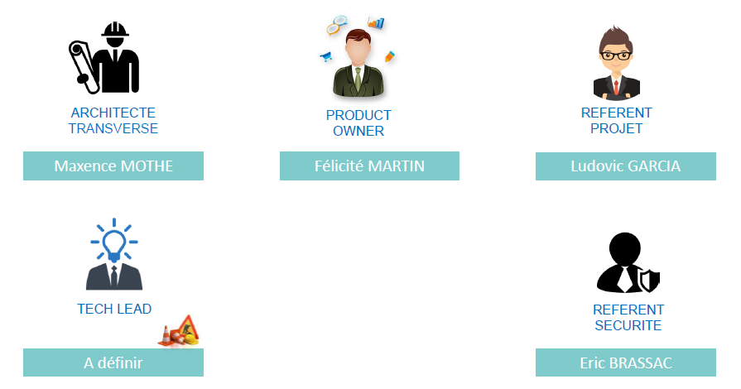

Security REPRESENTATIVE

PROJECT REPRESENTATIVEENT

To be defined

TRANSVERSE ARCHITECT

Organisation of Socle with respect to I3-PICA CAPGEMINIteams

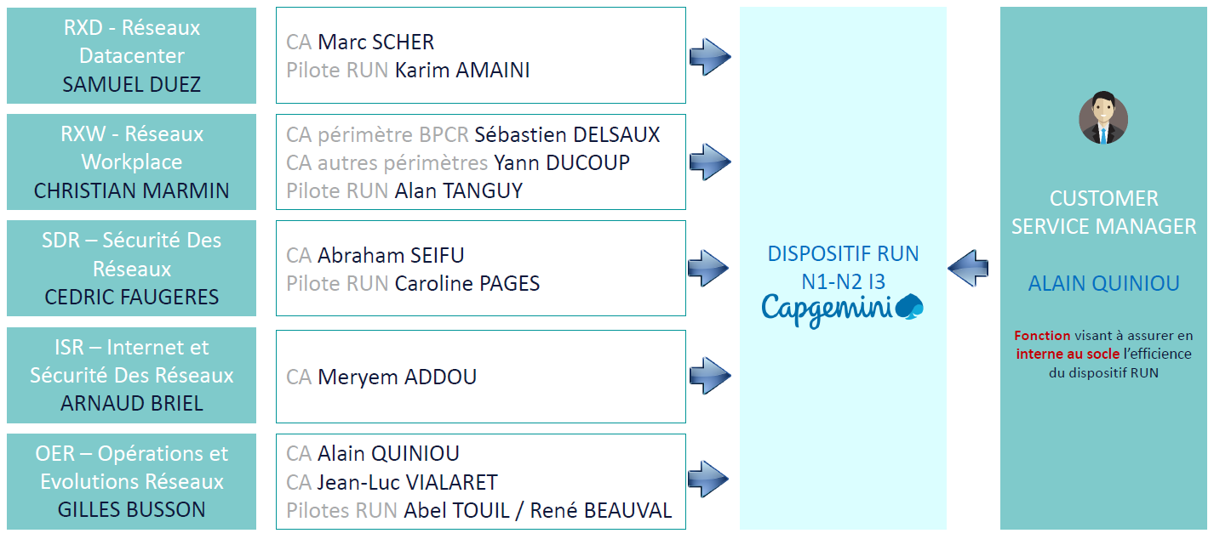

Works to ensures the efficiency of RUN plan within Socle

RUN PLAN